Kevin has a small piggy bank consisting of nickels and quarters. He counts the coins and finds he has 31 coins which total $6.95. Determine how many quarters and nickels Kevin has.

Try to solve this problem two different ways.

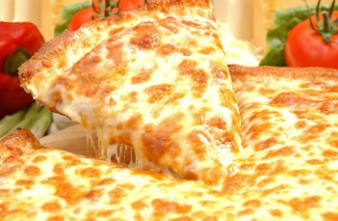
Colin ordered 2 types of pizzas for a party. He ordered 15 pizzas in total. The cheese pizza cost $11.50 and the meat-lovers pizza cost $15.25. The total cost for the pizzas including a $5 delivery charge is $200. How many of each of type of pizza did he buy?
Try to solve this problem 2 different ways.

