Unit 2: Chapter 4 - Equations
Section | Lessons | Description of Handouts/Activities | Textbook Exercises
4.1 | 1 | Solve Simple Equations.  - Solving Equations 1 | Pg 192 #1-9, 12, 15
4.2 | 2 | Solve Multi-Step Equations.  - Solving Equations 2 | Pg 200 #1, 2, 4, 5  Pg 201 #6-15
4.3 | 1 | Quiz #1 - sections 4.1-4.2  Solve Equations Involving Fractions.  - Solving Equations 3 | Handout Plus  Pg 208 #1, 3, 6, 10, 11, 13
4.4 | 1 | Modelling with Formulas.  - Formulas in Real Life  Assignment # 1 | Pg 215 #1-3, 8, 11-17, 19
4.5 | 2 | Modelling with Algebra.  - Using Equations to Solve Problems | Pg 226 #1-7, 9-10, 13, 15  Plus handout
Review | 2 | Quiz #2 – sections 4.3-4.5  - Summary of Unit 2 Learning Goals
Evaluation | 1 | Unit Test
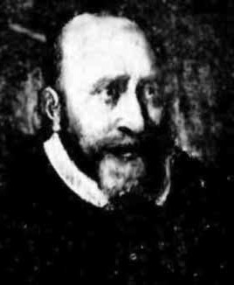
DID YOU KNOW…?
The symbol '=' was first used only in 1557!
It was the invention of a Welshman named Robert Recorde, the man who first introduced algebra to England.
Recorde used the symbol, composed of two parallel lines, in his 1557 book The Whetstone of Witte to avoid having to write over and over again "is equal to."
But the symbol didn't catch on right away. Some people preferred the symbol ' ||,' while others used the abbreviation ae or oe (for the Latin aequalis or "equal") into the 1700s.
As for Recorde himself, he died a debtor in King's Bench Prison.

