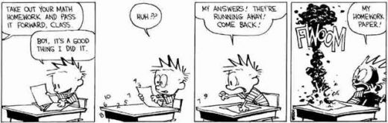

Unit 3: Chapters 2 and 5 – Linear Relations and Applications
Section | Lessons | Description of Handouts/Activities | Textbook Exercises
2.1 - 2.3 | 1.5 | Statistics  - Sources, Sampling and Displaying Data | Pg 45-46 #1bd,2c, 3ac,4,11 and  Pg 52-54 #6-8, 13 and  Pg 64-65 #1,2,3acd, 5
5.1 + 5.2 | 1 | Introduction to Partial and Direct Variation  - Exploring Linear Relations | Pg 242-243 #1-3,9ac,10 and  Pg 250-251 #1,2,6,7,10
5.3 | 1 | Investigating Slope  - The Slope of a Line | Pg 259-261 #1-5,8,9,14,15
5.4 + 5.5 | 1 | Quiz #1 - sections 2.1-2.2 and 5.1-5.3  Properties of Linear Relations  - Rate of Change and First Differences | Pg 268-269 #1-6,14  Pg 275-276 #1,2
5.6 | 1 | Connecting Variation, Slope and Differences  - The Rule of Four | Pg 284-286 #1,4,5,7,10,14
2.3 + 2.4 | 1 | Estimating and Analyzing Trends  - Visual Displays of Data  Assignment #1 | Pg 73-75 #2-4,6,8
2.5 | 1 | Comparing Relationships  - Linear vs. Non-Linear Relations | Pg 83-86 #1-3,5,10
2.6 | 2 | Applying Linear Models  - Distance vs. Time Graphs  Assignment #2 (In Class) | Pg 91-93 #1-5,7,8
Review | 1 | - Summary of Unit 3 Learning Goals
Evaluation | 1 | Unit Test

