# The Function named sin(θ)

**Trigonometric Basic Graphs**

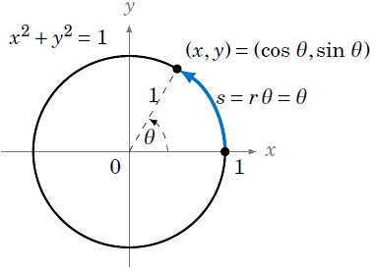We will describe a geometrical way to create the graph, using the unit circle. This is the circle of radius 1 in the $xy$-plane consisting of all $points (x, y)$ which satisfy the equation $x^{2} +{ y}^{2} = 1$.

We see in Figure 1 that any point on the unit circle has coordinates $(x, y) = (cos θ,sin θ),$ where $θ$ is the angle that the line segment from the origin to $(x, y)$ makes with the positive x-axis (by definition of sine and cosine). So as the point ( $x, y)$ goes around the circle, its y-coordinate is $sin θ.$

We thus get a correspondence between the y-coordinates of points on the unit circle and the values $f(θ) = sin θ$, as shown by the horizontal lines from the unit circle to the graph of $f(θ) = sin θ$ in Figure 2.

Figure

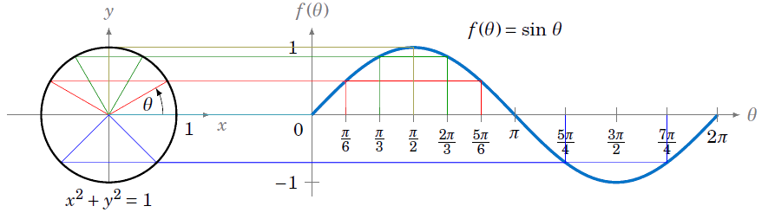

Figure

Notice the graph is positive (above the x-axis) when the trig. ratios of sine are in quadrant I and II and negative when the trig. ratios are in quadrant III and IV.

# If we rotate the circle in a clockwise direction, then the angles are represented using negative values. Use the CAST rule, sine is negative in quadrant III and IV and positive in quadrant I and II. Notice the graph represents this.

# Graph of y = sin x

# To see an interactive video, go to

# <http://www.intmath.com/trigonometric-graphs/1-graphs-sine-cosine-amplitude.php> and click “start”.

# The Function named cos(θ)

# To graph the cosine function, we could again use the unit ircle idea (using the x-coordinate of a point that moves around the circle), but there is an easier way. Recall that $\cos{x} = sin\left( \frac{π}{2}+x\right)$ for all $x.$ So $cos0$ has the same value as $sin \frac{π}{2}$, $cos \frac{π}{2}$ has the same value as $sin π$, $cos π$ has the same value as $sin \frac{3π}{2},$ and so on. In other words, the graph of the cosine function is just the graph of the sine function shifted to the left by $\frac{π}{ 2}$ radians, as in Figure 3.

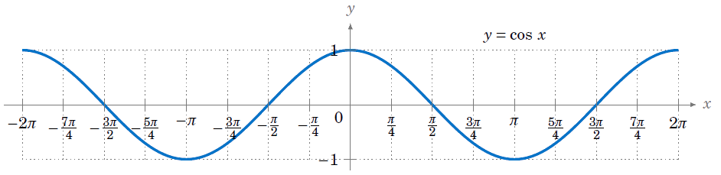

# To see an interactive video of the cosine curve use the same link as above but scroll down to start the next graph.

# The Function named tan(θ)

1. Complete the following table of values for  by using the trigonometric identity , to find the exact values for .
2. Sketch the graph of  using the values found in (A).

|  |  |  |  |  |  |  |  |  |  |  |  |  |  |  |  |  |  |
| --- | --- | --- | --- | --- | --- | --- | --- | --- | --- | --- | --- | --- | --- | --- | --- | --- | --- |
| **Value of θ**  **(radians)** | 0 |  |  |  |  |  |  |  | π |  |  |  |  |  |  |  | 2π |
| Exact Value  of sin(θ) | $$0$$ | $$\frac{1}{2}$$ | $$\frac{1}{\sqrt{2}}$$ | $$\frac{\sqrt{3}}{2}$$ | 1 | $$\frac{\sqrt{3}}{2}$$ | $$\frac{1}{\sqrt{2}}$$ | $$\frac{1}{2}$$ | $$0$$ | $$\frac{-1}{2}$$ | $$-\frac{1}{\sqrt{2}}$$ | $$\frac{-\sqrt{3}}{2}$$ | -1 | $$\frac{-\sqrt{3}}{2}$$ | $$-\frac{1}{\sqrt{2}}$$ | $$\frac{-1}{2}$$ | $$0$$ |
| Exact Value Of  cos(θ) | 1 | $$\frac{\sqrt{3}}{2}$$ | $$\frac{1}{\sqrt{2}}$$ | $$\frac{1}{2}$$ | $$0$$ | $$-\frac{1}{2}$$ | $$-\frac{1}{\sqrt{2}}$$ | $$\frac{-\sqrt{3}}{2}$$ | $$\frac{-\sqrt{3}}{2}$$ | $$\frac{-\sqrt{3}}{2}$$ | $$-\frac{1}{\sqrt{2}}$$ | $$-\frac{1}{2}$$ | $$0$$ | $$\frac{1}{2}$$ | $$\frac{1}{\sqrt{2}}$$ | $$\frac{-\sqrt{3}}{2}$$ | 1 |
| Exact Value Of  tan(θ) |  |  |  |  |  |  |  |  |  |  |  |  |  |  |  |  |  |



**θ**