**Slope as a Rate of Change and Making Connections – Day 2**

**⇨** A rate of change describes

⇨ A rate of change requires . When the relation is graphed then the

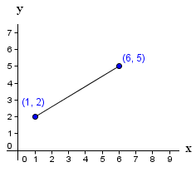describes the rate of change.

⇨ **Remember:**

Draw the right triangle using the two points.

**To find the slope of a line segment**

🡿

🡿

* join two points on the line
* subtract the______________ to get the

rise

* subtract the ________________ in

the same order to get the run.

⇨ rise = ⇨ run = slope =

**Example 1:** The cost of a pizza with tomato sauce and cheese is $9.00. It costs $0.75 for each additional topping.

1. Fill in the table showing the cost of pizza up to 8 additional toppings.
2. Graph the data. Be sure to join the points with a broken line. Explain why this is done.

**Cost of Pizza**

1. Using the two points $(2, 10.50)$ and $(4, 12)$, determine the:
   1. Rise =
   2. Run =
   3. Slope =
   4. Rate of change =
2. Write an equation representing the cost of the pizza.

Cost ($)

|  |  |
| --- | --- |
| **Number**  **Of Toppings** | **Cost ($)** |
| 0 |  |
| 2 | 10.50 |
| 4 | 12  Number of Toppings |
| 6 |  |
| 8 |  |

**Example 2:** **a)** Describe the relation between the two variables shown on the graph below.

**Distance Remaining in 3000 m Race**



**b)** Determine the following.

(i) Initial Value =

(ii) Slope =

Distance remaining (m)

(iii) Equation **=**

**c)** Interpret the slope as a rate of change.

Laps Completed

Number of Toppings

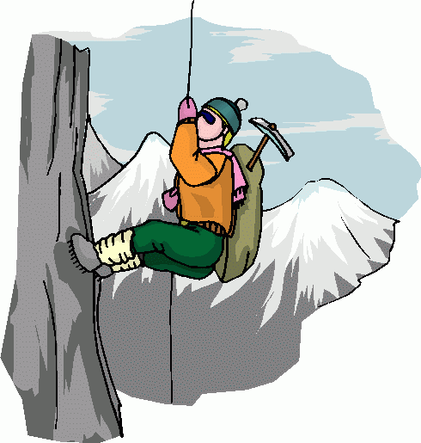**Example 3:** The temperature at which water boils depends on the altitude; that is the height above sea level. The table shows how the two quantities are related.

|  |  |  |  |  |  |  |
| --- | --- | --- | --- | --- | --- | --- |
| **Altitude (m)** | 0 | 1200 | 2400 | 3600 | 4800 | 6000 |
| **Boiling Point $°C$** | 100 | 96 | 92 | 88 | 84 | 80 |



1. Graph *Boiling point* vs. *Altitude*. Did you join the points with a broken line or a solid line? Explain.
2. Does this situation represent a partial or direct variation? Explain.
3. Determine the rate of change for this graph. Interpret its meaning.
4. Write an equation that models this situation. Be sure to define your variables.
5. Every year, tourists travel to Tanzania to climb Mount Kilimanjaro. Trekkers must boil their drinking water. Use your equation to determine the boiling point of water at camp Machame which is 3100 m above sea level.
6. Use your equation to determine the altitude for a boiling point of 60 $°$ C?

Laps completed

Laps completed