Sketching Graphs.

Name _________________ Date ______________

1. The graphs of two functions are given.
   1.  **b.**

***y***

***y***



***x***

***x***

In each case draw the graphs of the following functions.

* + - 1. 
      2. 

1. Use shifts to graph the following functions. Start from the basic graph.
   1. 
   2. 
   3. 

***y***

***y***



***x***

***x***

1. Write an equation for each function drawn below.

***y***



***x***

**A**: _____________________________ **B**: ____________________________

**C**: _____________________________ **D**: ____________________________

**E**: _____________________________

1. Use transformations to sketch the graph of the following functions.
   1. 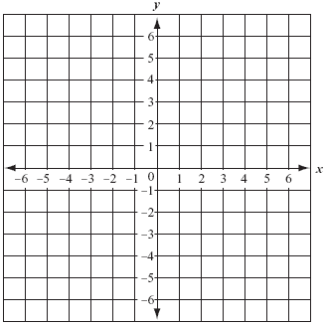 **b.** 