**Logarithmic scales in physical sciences.**

When quantities vary over very large ranges it is convenient to take their logarithms to get a more manageable set of numbers. For instance, this is done in pH scale, in the Richter scale and in the decibel scale.

**pH scale**

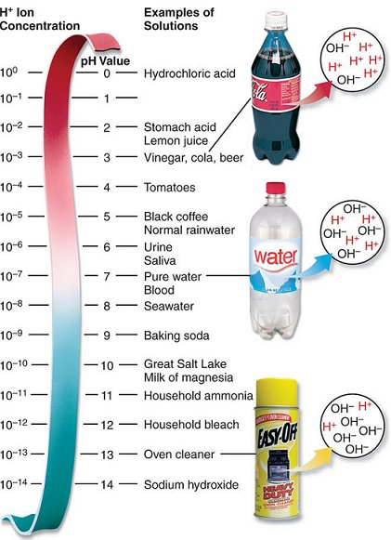

neutral

alkaline

acidic

The pH scale is a convenient way to quantify how acidic a solution is in terms of the H+  (hydrogen ion)  concentration. The amounts can range from  moles per litre to  moles per litre.

The pH is defined as



or



For example, H+ concentration of  corresponds to pH of – 1.

As the [H+ ] increases, the pH would go down. The more acidic a solution is, the lower the pH.

**Examples**

1. Nicole tests some apple juice and finds that the hydrogen ion concentration is [H+]=0.0003. Find the pH value and state whether the juice is basic or acidic.
2. Find the hydrogen ion concentration of a solution which has a pH of 2.26.
3. The pH value of liquid A is 3.8. The pH value of liquid B is 6.2. How many times as acidic as liquid B is liquid A?

**Richter scale**

The Richter scale measures the intensity of earthquakes – their magnitude. It is defined as



where *I*  is the intensity of the earthquake and  *I0* is the intensity of a “standard” (low-level) earthquake.

**Examples**

1. Austin has a seismograph set up at home. He sees that there was an event while he was away on holiday that had an intensity of $I=989I_{0}$. Given that a heavy truck rumbling by can cause a micro quake with a Richter rating of 3 or 3.5, and “moderate” quakes have a Richter rating of 4 or more, what was likely the event that occurred while Austin was away?
2. 1. Early in the 19th century the earthquake in San Francisco registered 8.3 on the Richter scale. In the same year, another earthquake was recorded in South Africa that was four times stronger. What was the magnitude of the earthquake in South Africa?
   2. A recent earthquake in San Francisco measured 7.1 on the Richter scale. How many times more intense was the San Francisco earthquake described in part **a**.

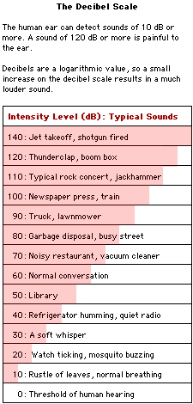

**Decibel scale**

The loudness of a sound is defined as



where *I*  is the intensity of the sound and is the intensity of a barely audible sound. A barely audible sound has an intensity of .

The difference in sound levels can be found using the formula



where  is the difference in sound levels, in decibels, and is the ratio of their sound intensities. The loudness (volume)  is measured in decibels (dB) and intensity *I* is measured in W/m2

The decibel scale, dB, also a logarithmic scale, measure sound levels. The human ear can detect a very wide range of sounds, ranging from a soft whisper to loud machinery. Humans are equipped with very sensitive ears capable of detecting sound waves of extremely low intensity. The faintest sound a human ear can detect has an intensity of 1x watts/m2. A sound with this intensity corresponds to a sound, which will displace particles of air by a mere one-billionth of a centimetre. This faintest sound the ear can detect is called the threshold of hearing (TOH). The most intense sound, which the ear can safely detect without suffering any physical damage, is more than one billion times more intense than the TOH.

Our ear is divided into three connecting sections: the outer, middle, and inner ear. The outer ear funnels noise to the eardrum. In the middle ear, three tiny bones transmit sound to the inner ear. In the inner ear, sound waves are converted to readable nerve impulses by approximately 16 000 hair-like receptor cells, which sway with the sound waves. These cells can be severely damaged by loud sounds, resulting in permanent hearing loss. If you lose one third of these cells, your hearing will be significantly impaired. Hearing loss is progressive. Some hearing loss is inevitable with age, but we would lose much less if we protected our ears at the appropriate times.

**Examples**

1. An alarm has an intensity of $5.8×{10}^{-9} W/m^{2}$. How loud is the alarm in decibels?
2. A cat’s purr is about 316 times as intense as threshold sound. Determine a decibel rating of the cat’s purr.
3. How many times louder is a music concert of 125 dB than a conversation of 53 dB?

**Applications of Exponential and Logarithmic Functions**

1. **Earthquakes.** Compare the intensity of the 1964 Alaska earthquake with the intensity of the 1966 Turkey earthquake.
2. On July 26, 1986, an earthquake with magnitude 5.5 hit California. The next day a second earthquake with magnitude 6.2 hit the same region. How many times as intense as the first earthquake was the second earthquake.
3. **Acid rain.** A lake in the Muskoka region of Ontario has a pH of 4.0. How many times as acidic as clean rain water, which has a pH of 5.6, is the water in this lake?
4. Elena tests some ammonia and determines the hydrogen ion concentration to be $[H+]=1.3×{10}^{-9}$. Find the pH value and state whether the ammonia is basic or acidic.
5. When the pH of the water in a lake falls below 4.7, nearly all species of fish in the lake are deformed or killed. How many times as acidic as clean rainwater, which has a pH of 5.6, is such a lake?
6. **Sounds.** How many times more intense than a shout is the sound of maximum stereo output?
7. The sound level at a rock concert is about 10 500 times more intense than a normal conversation. What is the sound level at the rock concert, in decibels?
8. The park rangers at a wildlife refuge have been keeping track of the bear population in the park. If they’ve noticed that the annual growth rate is 4% and there are currently 8 bears in the park, how many years will it take for the bear population to reach 20? Round your answer to two decimal places.
9. Sociologists have found that the gossip spreads among a population of people at an exponential rate. Suppose that the function represents the number of people P in Rumorville (population 487) who have heard the latest gossip t hours after the gossip was first told. How many hours will it take for the gossip to be spread among 350 people? ($e≈2.718281828$)
10. If the initial temperature of an electric oven is 95ºC and its temperature decreases 27% every minute after it is turned off. How long will it take for the oven to cool down to room temperature?
11. *Answers*
12. 1. Alaska’s was 39.8 times as intense 2. 5 times 3. 39.8 times 4. 8.9, basic 5. 7.9 times 6. 100 times 7. 100.2 decibels 8. 23.36 years 9. 23 hours 56 min 10. 4 h 48 min