Unit 2 - Lesson 4

Date:

Formulas in Real Life

IMPORTANT DEFINITIONS :

**What can we do with formulas?**

**Formula:**

Describes an algebraic relationship between two or more variables

**What does it mean to** "Rearrange a formula *in terms* of a variable"?

It means to express the formula with that variable being isolated.

**Did you know:**

Formulas are not only used in Math but also in Physics, Chemistry and Computer Science just to name a few.

Formulas can be rearranged to isolate different variable. This is particularly useful when you know the value of all of the variables except one and are seeking the value of that one remaining variable.

**Brainstorm!!!** - What formulas do you know?

**Example 1**

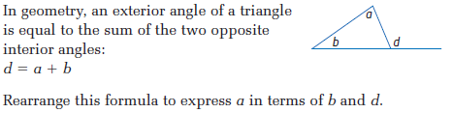

**Example 2**



**Example 3**



LEARNING GOALS:

I understand what it means to rearrange a formula *in terms* of a specific variable

I can use opposite operations to rearrange a formula to isolate any variable in the equation

**Let's try some together:**

1. Isolate the variable indicated

a)  , for *d* b)  , for *m* c)  , for *r*

d) $P=2(l+w)$, for e) , for

2. The kinetic energy (energy due to motion) of an object depends on its mass and how fast it is moving, the formula  is a formula that relates energy with mass and velocity (speed). Show Bill how to express *v* in terms of *E* and *m*.