Warm-up Activity – Think back a few lessons when we discussed scatter plots and lines of best fit.

Linear and Non Linear Relationships Plus Scatterplots

Recall that data that forms a relatively straight line on a scatter plot indicates a linear relationship between the variables.

Lines of best fit do a good job at following the trend of linear relationships but do a poor job if the relationship is non-linear.

You can use a curve of best fit to approximate the trend in some non-linear relationships.

➀ *Circle the correct words describing the relationship shown in the scatter plot.*

➁ *For each graph draw the line or curve of best fit.*

*Note: If you circle "none", then that is the only word that need be circled for that graph.*

|  |  |  |
| --- | --- | --- |
| 1.    The linear relationship is…  very strong / strong / weak / none  linear / non-linear  positive / negative | 2.    The linear relationship is…  very strong / strong / weak / none  linear / non-linear  positive / negative | 3.    The linear relationship is…  very strong / strong / weak / none  linear / non-linear  positive / negative |
| 4.    The linear relationship is…  very strong / strong / weak / none  linear / non-linear  positive / negative | 5.    The linear relationship is…  very strong / strong / weak / none  linear / non-linear  positive / negative | 6.    The linear relationship is…  very strong / strong / weak / none  linear / non-linear  positive / negative |

**Example 1 - Discuss**

Why is a line of best fit not a good model for the data in each scatter plot.

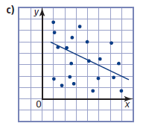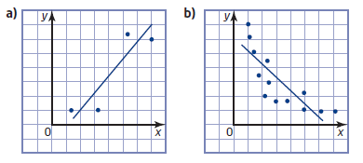

**Example 2 – Draw a curve of best fit and describe the trend in the data.**



**Example 3**

Amount of Caffeine over time

|  |  |
| --- | --- |
| Time  (h) | Mass of Caffeine (mg) |
| 0 | 200 |
| 6 |  |
| 12 |  |
| 18 |  |
| 24 |  |

A typical Canadian adult consumes about 200 mg of caffeine a day.

Caffeine has a half-life of about 6 h. *This means* that about 6 h after consumption half the caffeine remains in a person’s body.

1. Complete the table below to show how much caffeine is left in a person’s body over time.
2. Describe the type of relation that is produced? How do you know?
3. Graph and describe the relation .
4. About how much caffeine will remain:

|  |  |  |  |  |  |  |  |  |  |  |  |  |  |  |  |  |  |  |
| --- | --- | --- | --- | --- | --- | --- | --- | --- | --- | --- | --- | --- | --- | --- | --- | --- | --- | --- |
|  |  |  |  |  |  |  |  |  |  |  |  |  |  |  |  |  |  |  |
|  |  |  |  |  |  |  |  |  |  |  |  |  |  |  |  |  |  |  |
|  |  |  |  |  |  |  |  |  |  |  |  |  |  |  |  |  |  |  |
|  |  |  |  |  |  |  |  |  |  |  |  |  |  |  |  |  |  |  |
|  |  |  |  |  |  |  |  |  |  |  |  |  |  |  |  |  |  |  |
|  |  |  |  |  |  |  |  |  |  |  |  |  |  |  |  |  |  |  |
|  |  |  |  |  |  |  |  |  |  |  |  |  |  |  |  |  |  |  |
|  |  |  |  |  |  |  |  |  |  |  |  |  |  |  |  |  |  |  |
|  |  |  |  |  |  |  |  |  |  |  |  |  |  |  |  |  |  |  |
|  |  |  |  |  |  |  |  |  |  |  |  |  |  |  |  |  |  |  |
|  |  |  |  |  |  |  |  |  |  |  |  |  |  |  |  |  |  |  |
|  |  |  |  |  |  |  |  |  |  |  |  |  |  |  |  |  |  |  |

* 1. after 9 h?
  2. after 40 h?

What assumption did you make?

**Example 4**

|  |  |
| --- | --- |
| **Speed (km/h)** | **Minimum stopping Distance (m)** |
| 20 | 2 |
| 40 | 8 |
| 60 | 18 |
| 80 | 31 |
| 100 | 49 |

A car’s stopping distance depends on many factors, including its speed before braking, the road conditions, the type of road surface, and the condition of the brakes and tires. The table shows minimum stopping   
distances for a car travelling on dry pavement, to the nearest metre.

1. Is the relation linear? Explain.
2. Graph the data.

|  |  |  |  |  |  |  |  |  |  |  |  |  |  |  |  |  |  |  |  |
| --- | --- | --- | --- | --- | --- | --- | --- | --- | --- | --- | --- | --- | --- | --- | --- | --- | --- | --- | --- |
|  |  |  |  |  |  |  |  |  |  |  |  |  |  |  |  |  |  |  |  |
|  |  |  |  |  |  |  |  |  |  |  |  |  |  |  |  |  |  |  |  |
|  |  |  |  |  |  |  |  |  |  |  |  |  |  |  |  |  |  |  |  |
|  |  |  |  |  |  |  |  |  |  |  |  |  |  |  |  |  |  |  |  |
|  |  |  |  |  |  |  |  |  |  |  |  |  |  |  |  |  |  |  |  |
|  |  |  |  |  |  |  |  |  |  |  |  |  |  |  |  |  |  |  |  |
|  |  |  |  |  |  |  |  |  |  |  |  |  |  |  |  |  |  |  |  |
|  |  |  |  |  |  |  |  |  |  |  |  |  |  |  |  |  |  |  |  |
|  |  |  |  |  |  |  |  |  |  |  |  |  |  |  |  |  |  |  |  |
|  |  |  |  |  |  |  |  |  |  |  |  |  |  |  |  |  |  |  |  |
|  |  |  |  |  |  |  |  |  |  |  |  |  |  |  |  |  |  |  |  |
|  |  |  |  |  |  |  |  |  |  |  |  |  |  |  |  |  |  |  |  |
|  |  |  |  |  |  |  |  |  |  |  |  |  |  |  |  |  |  |  |  |
|  |  |  |  |  |  |  |  |  |  |  |  |  |  |  |  |  |  |  |  |
|  |  |  |  |  |  |  |  |  |  |  |  |  |  |  |  |  |  |  |  |
|  |  |  |  |  |  |  |  |  |  |  |  |  |  |  |  |  |  |  |  |
|  |  |  |  |  |  |  |  |  |  |  |  |  |  |  |  |  |  |  |  |

1. Use the curve of best fit.

**Interpolate** the stopping distance for a speed of 50 km/h.

**Extrapolate** to predict the speed for a minimum stopping distance of 60 m.

1. Describe the trend of the data.

**Example 5**

In the Kingdom of Petrodalla, natural gas is the primary resource. The table shows the amount of natural gas produced each year.

1. Plot the data and draw a curve of best fit.
2. Describe how the production of gas changes over time.

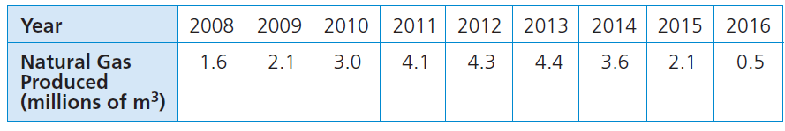

LEARNING GOALS:

🞐 I can add and use a line / curve of best fit to predict values within and beyond my data.

🞐 I can compare two set of data by describing any trends that are visible in a scatter plot.