**Practice: Function Notation. Domain and Range.**  Name: Date:

1. Each of the following has at least one incorrect statement about domain and/or range. Correct mistakes.
2. 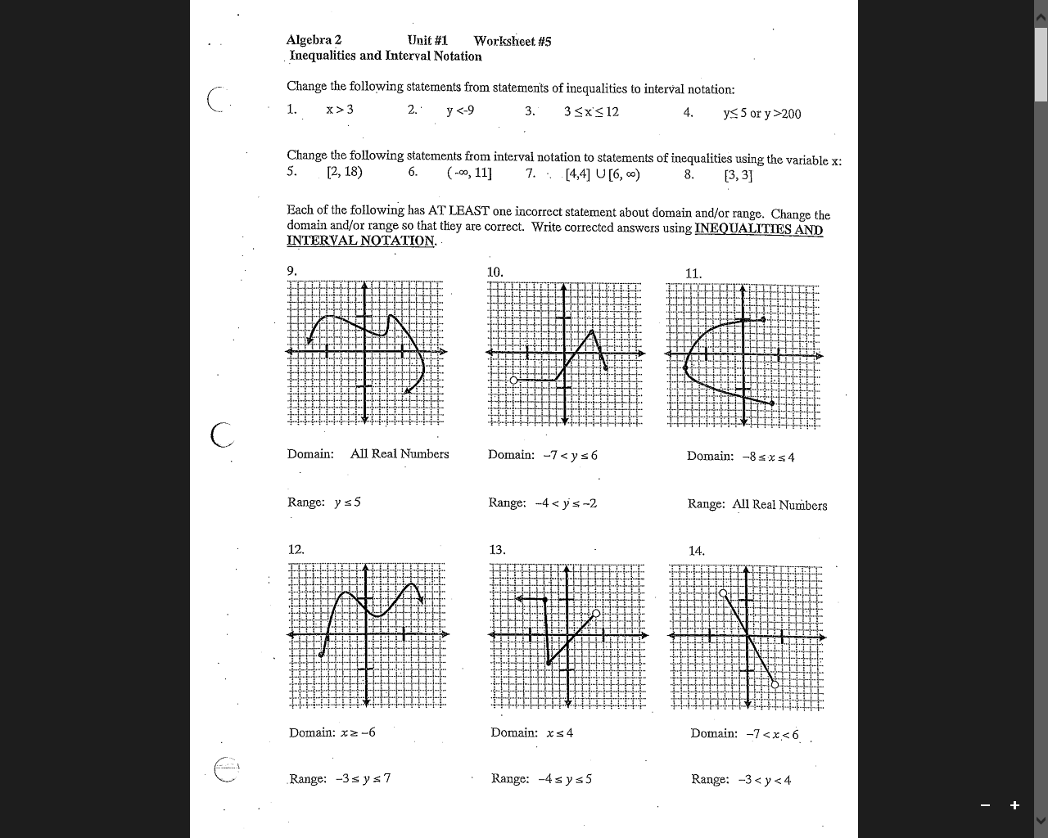 **b)** **c) d)**

|  |  |  |  |
| --- | --- | --- | --- |
| Domain: $x∈R$ | Domain: $x∈R -7<x≤6$ | Domain: $x∈R -8≤x≤4$ | Domain: $x∈R -7<x<6$ |
| Range: $y∈R y ≤5$ | Range: $y∈R -4<y≤-2$ | Range: $y∈R$ | Range: $y∈R -3<y<4$ |

1. Consider the following functions ,and .

|  |  |
| --- | --- |
| 1. Find | 1. Find |
| 1. Find | 1. Find |
| 1. Find | 1. Find |
| 1. Find a positive *x* so that | 1. Find *x* so that |

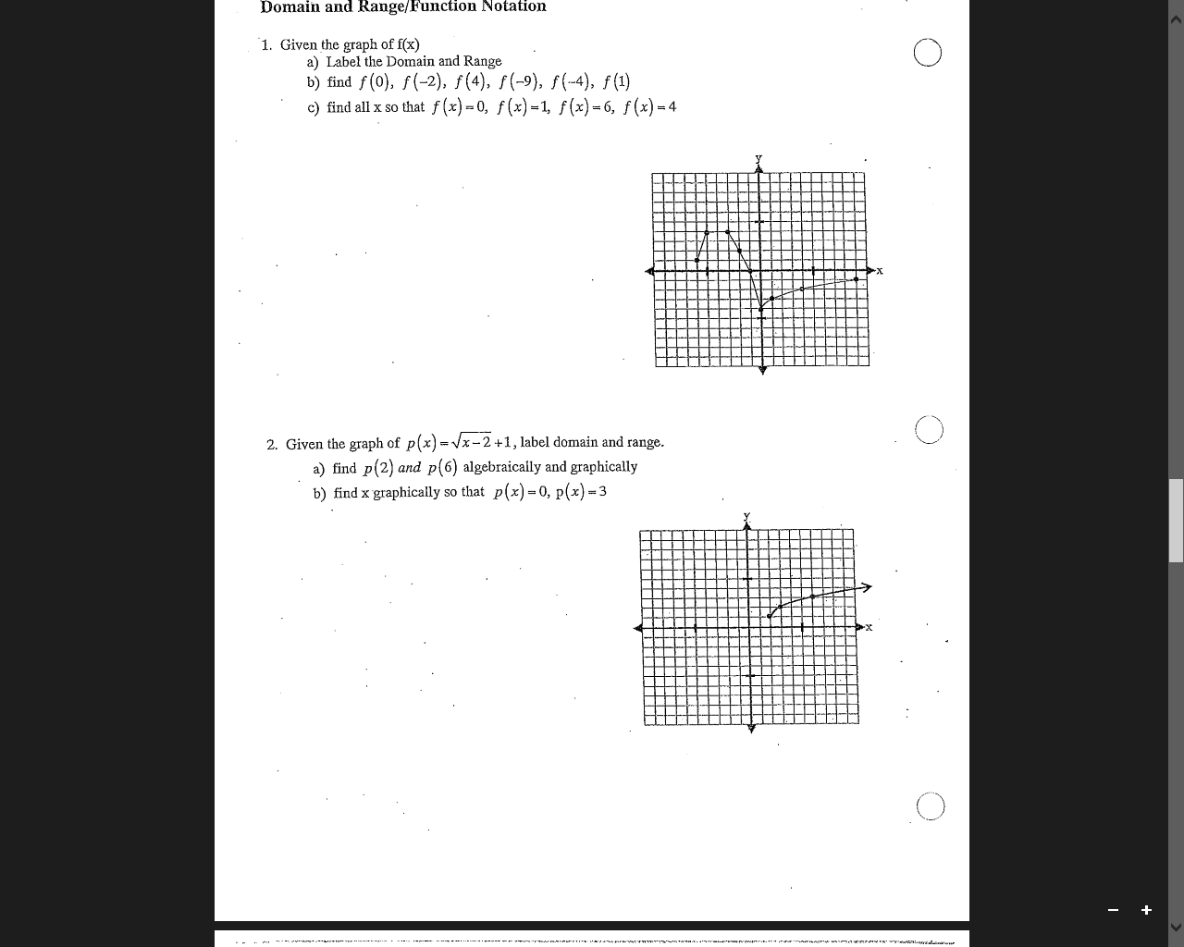

1. Consider the graph of .
   1. State the domain and range.
   2. Find algebraically and graphically.
   3. Find *x* graphically so that .
2. Consider the graph of the function below, determine the following output and input values.

|  |  |  |
| --- | --- | --- |
|  |  |  |
|  |  |  |
|  | 1. (only positive value of *x*) | $f\left(x\right)=0$ |

