Double Angle Formulas

Written below are the three double angle identities for sine, cosine and tangent. Note there are 3 identities for $cos2x$. There is no need to memorize all three of them, as the last two can always be determined by using the Pythagorean identity $\sin^{2}x+\cos^{2}x=1$ and isolating for either $\sin^{2}x$ or $\cos^{2}x$.

$$sin2x=2sinxcosx$$ | $$cos2x={\left\{\begin{aligned}\cos^{2}x-\sin^{2}x \\ \\ 1-2\sin^{2}x \\ \\ 2\cos^{2}x-1\end{aligned}\right.}^{}$$
$$tan2x=\tan\left(x+x\right)=\frac{tanx+tanx}{1-tanx(tanx)}$$

Before we start working with these identities, let’s demonstrate why these work.

Ex 1: Let $x=60°$. Show that the above identities are true.

Note: $sin2x≠2sinx$ ; similarly $cos2x≠\frac{1}{2}cosx$

Ex 2: Write an equivalent expression for the following using a double identity.
a) $cos4x$ b) $sin6x$ c) $cos\left(\frac{2}{3}x\right)$

Ex 3: Express as a single cosine or sine function.
a) $8 sin2x cos2x$ b) $1-2\sin^{2}\left(\frac{3}{2}x\right)$ c) $10\cos^{2}\left(\frac{1}{3}x\right)-5$

Ex 4: If $sinx=\frac{4}{5}$ , $\frac{π}{2}<x<π$ , find the value of $sin2x.$

Ex 5: If $cosx=\frac{2}{3}$ , find the value of $cos4x$. What quadrant does 4x lie in?

Ex 6: Evaluate using exact values.

a) $sin\left(\frac{9π}{8}\right)$ b) $cos\left(-\frac{5π}{8}\right)$

Half Angle Formulas

We know $cos2x=2\cos^{2}x-1$ so that $cosx=2\cos^{2}\left(\frac{1}{2}x\right)-1$.
Isolating for $cos\left(\frac{1}{2}x\right)$ we get:
$$cosx+1=2\cos^{2}\left(\frac{1}{2}x\right)$$
$$\frac{cosx+1}{2}=\cos^{2}\left(\frac{1}{2}x\right)$$
$$±\sqrt{\frac{cosx+1}{2}}=cos\left(\frac{1}{2}x\right)$$

Ex 7: Evaluate $cos\left(\frac{7}{12}π\right)$ using exact values.

Ex 8: Find the exact values of $cos\left(\frac{x}{2}\right)$ if $sinx=-\frac{3}{5}$ where $π<x<\frac{3}{2}π$. What quadrant does the angle lie?

Ex 8: Prove $sin\left(\frac{1}{2}x\right)=±\sqrt{\frac{1-cosx}{2}}$

Ex 9: Prove $tan\left(\frac{1}{2}x\right)=\frac{sinx}{1+cosx}$

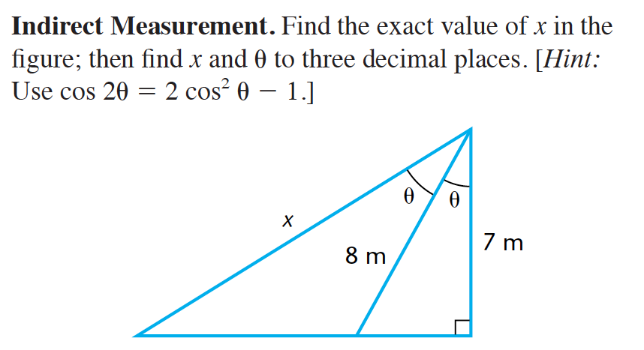
Ex 10:

